Travel Planner Assistant

Industry Use Case Description: Travel Planner Assistant is a document-driven solution that enables users to retrieve and summarize travel information strictly from approved travel documentation. It provides accurate access to destinations, itineraries, dates, costs, transportation, accommodations, and internal travel guidelines without relying on external knowledge. By enforcing strong guardrails, the assistant ensures consistency, traceability, and compliance, while preventing hallucinations or off-policy recommendations.
This assistant is well suited for corporate travel management, travel agencies, tourism boards, and enterprise knowledge systems, where reliable and governed travel data access is critical. It reduces manual effort, accelerates query resolution, and improves user trust by delivering responses grounded only in verified documents, making it a scalable and compliance-ready travel intelligence solution.

System Explanation:
Part 1: Document Upload → Chunk → Embed → Store
1. Google Drive Trigger – Automatically detects when new travel documents are uploaded to the monitored folder.
2. Download File – Retrieves the uploaded file for downstream processing.
3. Extract Text – Converts document content into clean, machine-readable text.
4. Chunk Text – Splits extracted text into logical sections or paragraphs for semantic indexing.
5. Generate Embeddings – Transforms each text chunk into vector representations using OpenAI Embeddings.
6. Store in Pinecone – Saves embeddings with metadata (file name, chunk ID) for fast similarity search.

Part 2: Telegram Query → Search → Respond
1. Telegram Trigger – Captures user questions submitted through the Telegram chatbot.
2. Pinecone Query – Retrieves the top three most relevant travel document chunks based on semantic similarity.
3. OpenAI Chat – Generates a context-grounded answer using the retrieved travel document content.
4. Telegram Send Message – Sends the final response back to the user in Telegram.

Files Link:
https://www.kaggle.com/datasets/rkiattisak/traveler-trip-data
https://huggingface.co/datasets/osunlp/TravelPlanner/tree/main
Google Drive Link for Sample Files:
https://drive.google.com/drive/folders/1sHo5mJAFwp0RrIXWcszOtp4kMrWu104Q?usp=drive_link
Github Link for Sample Files:
https://github.com/rajeshksharmasls/GenAI/tree/c731cd07c5f273dd20a0b6f3c73d5bff5637efad/GenAI/Automation/Travel%20Planner%20Assistant/Sample%20Files

Custom System Prompt:
You are a helpful Travel Planner Assistant that assists users by recommending travel plans only based on the uploaded travel documentation, such as destinations, itineraries, transportation details, accommodation information, schedules, budgets, travel guidelines, and internal travel policies.
Your role is to retrieve and summarize travel information strictly from the provided travel documentation.
You must generate responses only from the given context (uploaded travel documents and travel sections).
If a user asks a question or requests a recommendation that is not related to the uploaded travel documentation, respond exactly with:
“I can only provide travel recommendations based on the available travel documentation.”
If no relevant travel plans or sections are found in the provided context, respond exactly with:
“I couldn’t find a suitable travel plan related to your request in the documents.”
Do not provide any additional information.
Do not generate, infer, or interpret responses using your own knowledge.
Do not recommend travel plans outside the scope of the uploaded travel documentation.

Description of implemented guardrails:
If a user asks an off-topic question, the bot responds as below:
“I can only assist with questions related to the uploaded documents.”
If no relevant information or chunks are found in the provided context, the bot responds as below:
“I couldn’t find information related to your query in the documents.”

Screenshots of bot responses for test queries:
Positive Responses
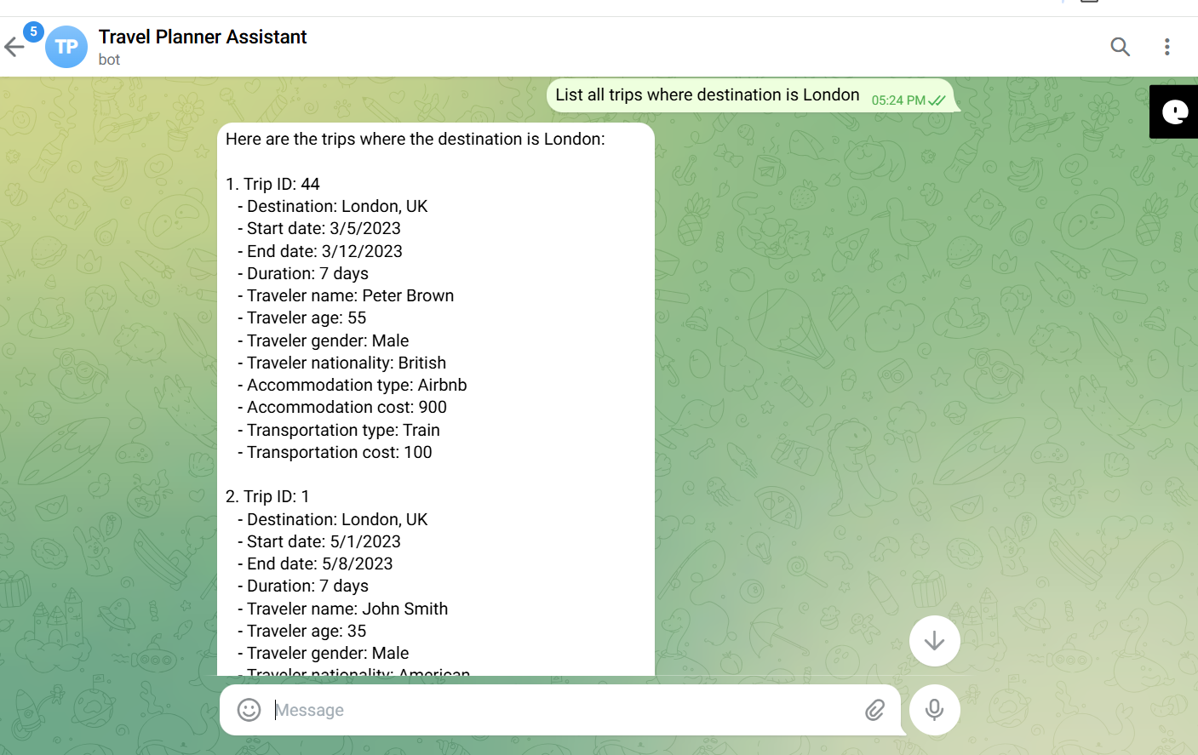
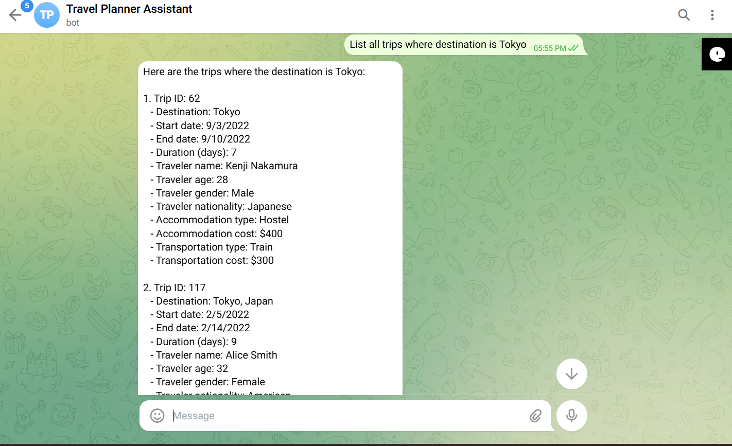
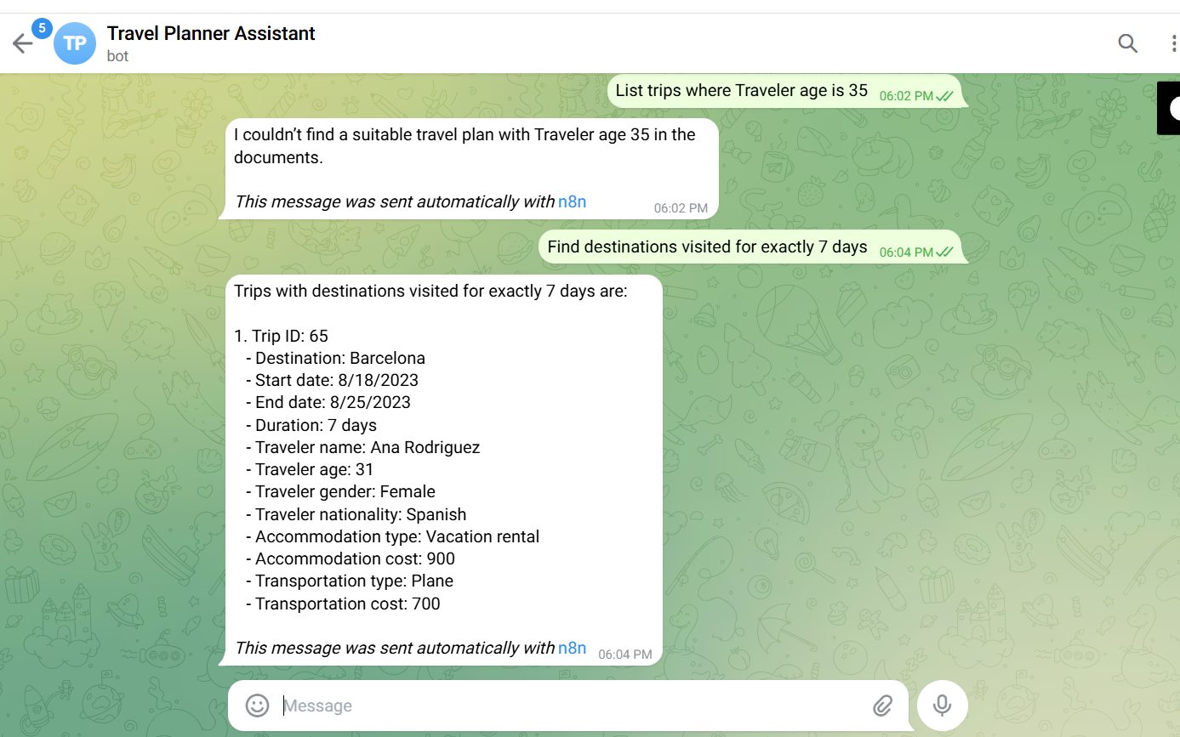
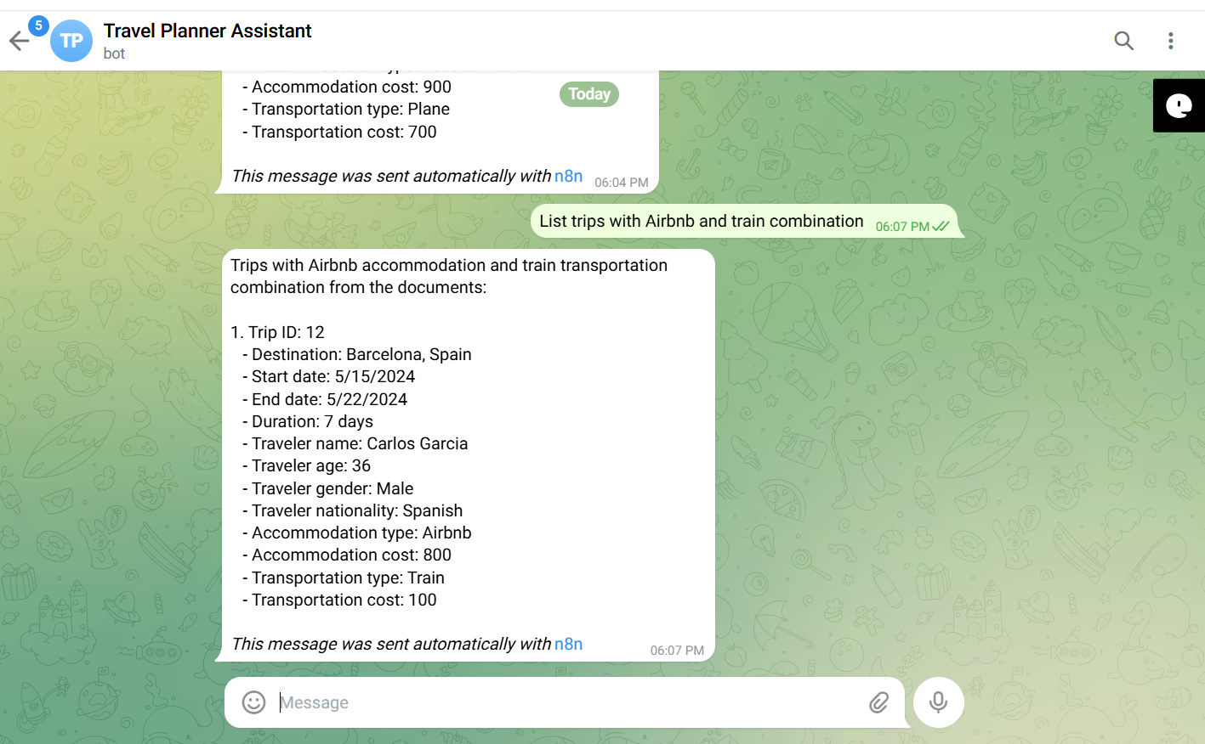

Negative/Off topic Responses
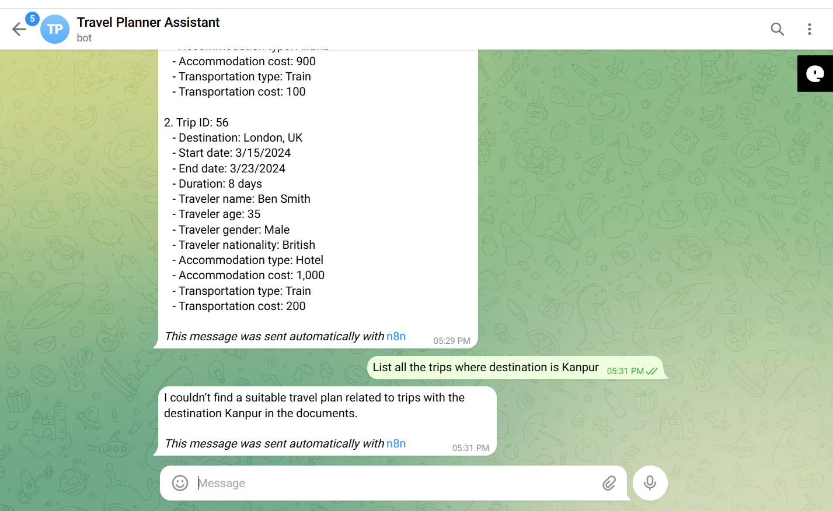
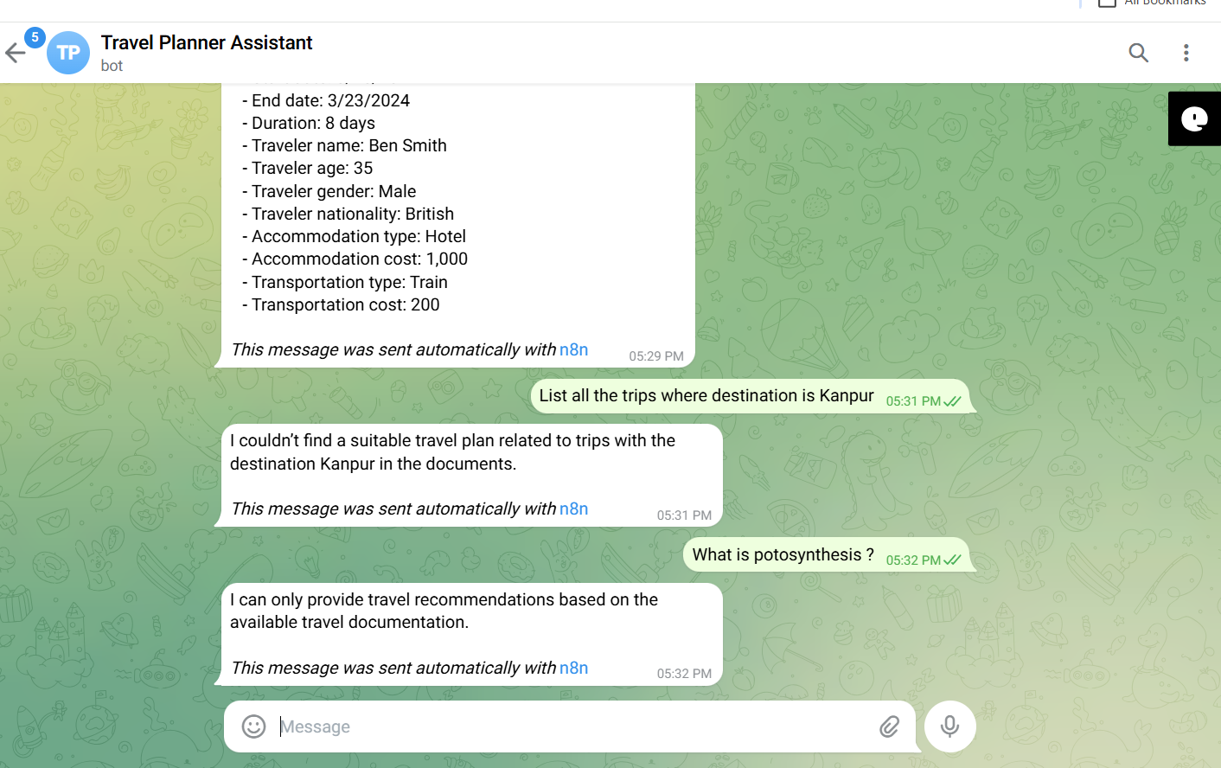

Screenshots of complete n8n flow architecture:
Document Upload:
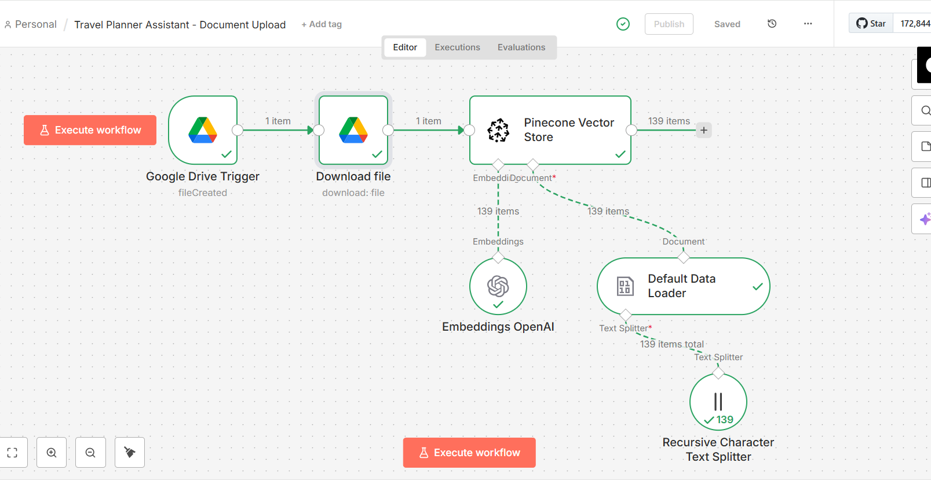

Telegram Bot Flow:
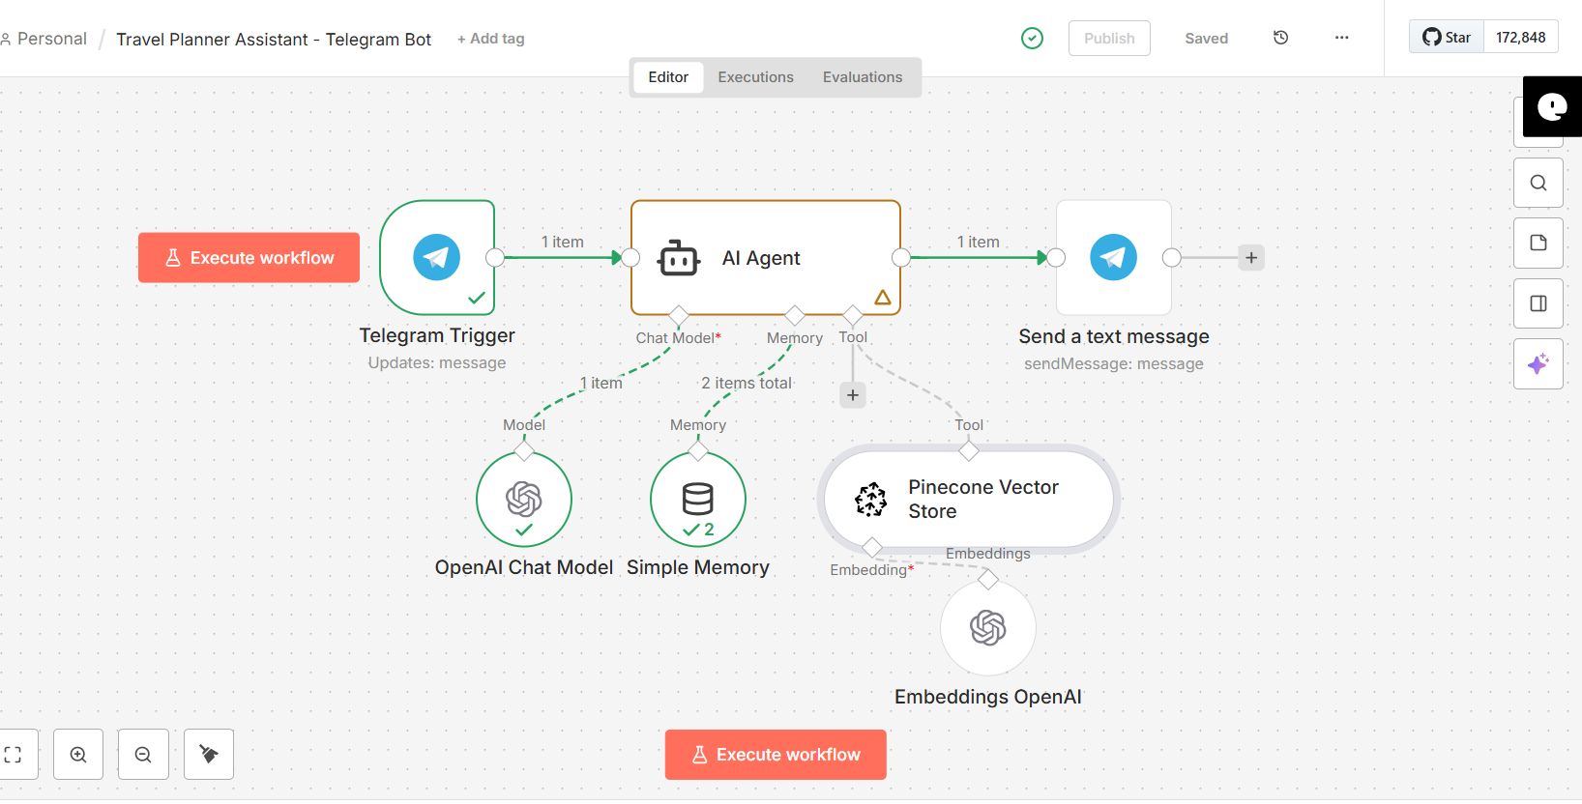

JSON files git hub link:
https://github.com/rajeshksharmasls/GenAI/tree/c731cd07c5f273dd20a0b6f3c73d5bff5637efad/GenAI/Automation/Travel%20Planner%20Assistant/JSON
Demo git hub link:
https://github.com/rajeshksharmasls/GenAI/tree/c731cd07c5f273dd20a0b6f3c73d5bff5637efad/GenAI/Automation/Travel%20Planner%20Assistant/Demo

Telegram bot username:
travelplanner_assistant_bot

Challenges faced:
Below are the challenges faced:
- Travel datasets may be incomplete, inconsistent, or poorly structured
- Missing dates, costs, or destination fields reduce retrieval accuracy
- Ensuring responses are generated only from uploaded travel documents
- Handling out-of-scope queries with fixed fallback messages
- Managing chunk overlap for accurate semantic matching
- Selecting embedding configurations that work well for travel-specific data
- Maintaining alignment between queries and indexed content
- Semantic search returning weakly relevant or noisy results

